**Google Drive widget**

**Manual Installation**

1. Copy **com.temenos.widgets.google.drive**folder in your widgets folder (Ex: /{your project/templates })
2. Restart IDE.

**Auto-Installation**

1. Run IDE.
2. Make sure the “**Switch Monitor on/off**” is checked.
3. Download/ Copy the widget (**com.temenos.widgets.google.drive.zip**) to monitored folder.

(**Tools** menu, **Options**, **Auto-install** tab and set in “**Download Location**” the folder where you copied the widgets.) No need to restart IDE.

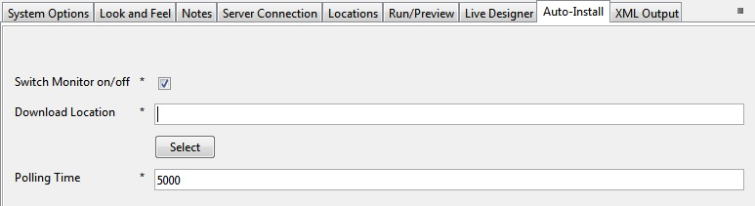

**Overview**

The **Google Drive**'s widget allows users to share files and folder from their google Drive account within a web site (see the below image – list view).

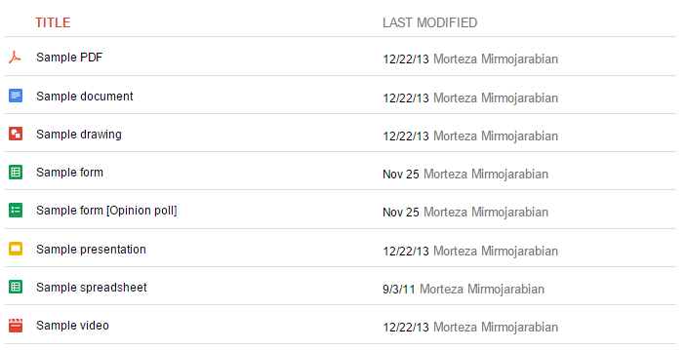

1. You have to insert a new display Item of **Google Drive** type in the **Presentation Editor**
2. Within Widget Details tab you have to set up the widget settings.

* **folderID –** The identifier of your Google Drive Folder . To obtain the ID of a folder you could follow next steps :

Go to Google Drive Website >> open the folder >> look at its URL in the address bar of your browser. For example:

Folder URL: https://drive.google.com/#folders/**0B1iqp0kGPjWsNDg5NWFlZjEtN2IwZC00NmZiLWE3MjktYTE2ZjZjNTZiMDY2**

You could extract Folder ID from the Folder URL:

Folder ID : **0B1iqp0kGPjWsNDg5NWFlZjEtN2IwZC00NmZiLWE3MjktYTE2ZjZjNTZiMDY2**

This folder could be accessed by the other users only if has permission that allow to be accessed ( either by the public or private) . For more details about sharing settings you could find on these URLs

<https://support.google.com/drive/answer/2494886?hl=en>

<https://support.google.com/drive/answer/2494822>

* **List** - Google Drive folders can be embedded and displayed in list and grid views
* **Width -** The width of the widget.
* **Height –** The height of the widget.

